Job Role Name QP Code (Level) | Assistant Mason (CON/Q0102) | Batch Name/Id
Duration: | 9:00 AM to 5:00 PM | Max Marks: | 600
Name of Candidate |  | Candidate Signature
Assessor Name |  | Aadhaar Number
Assessor Signature |  | Trainer Signature
TP Name |  | TC Name
TP/TC Stamp with Signature |  | Date

Total Obtained Marks:.................... /600
NOS | Theory |  | Practical & Viva
NOS | Full Marks | Marks Obtained | Full Marks | Marks Obtained
CON/N101 | 30 |  | 70
CON/N105 | 30 |  | 70
CON/N106 | 30 |  | 70
CON/N107 | 30 |  | 70
CON/N8001 | 30 |  | 70
CON/N9001 | 30 |  | 70
Total | 180 |  | 420

INSTRUCTIONS TO THE CANDIDATES

- No candidate will leave the examination Hall/Centre before the 17:00. If any candidate leaves center before 17:00 will be counted absent.
- Write your name, Aadhaar Number, father name, Signature clearly in the designated space.
- The enclosed paper contains 2 sections Theory, & Practical Marks are mentioned against each question.
- Use of Calculators/ Mobile Phone is not permitted during assessment.
- Use only Black or Blue ball point pen. Don't do any rough work in paper.
- Do not mark multiple answers for one question, in case of multiple marking; you will not be given any marks for that particular question.
- To pass the qualification pack, every trainee should score a minimum of 50% of aggregate marks to successfully clear the assessment

CON/N0101: Erect and dismantle temporary scaffold up to 3.6 meter height (30Marks)
Q1. Which of the following is a part of Cuplock System? (4 Marks)
- Base Jack
- Bracing
- Toe-guard
- All of the above
Q2. Why is it important to use proper components and follow standard procedures when erecting a temporary scaffold? (4 Marks)
- It looks more aesthetically pleasing
- It reduces the risk of accidents and injuries
- It allows for quick dismantling of the scaffold
- It helps in saving construction costs
Q3. Which tool is commonly used for erecting and dismantling scaffolding? (6 Marks)
- Screwdriver
- Hammer
- Pliers
- Tape measure
Q4. Which type of scaffolding is NOT typically used for erecting and dismantling a 3.6-meter temporary scaffold? (6 Marks)
- Pipe scaffolding
- Cup lock scaffolding
- H-frames scaffolding
- Bamboo scaffolding
Q5. Which component of temporary scaffolding is used to prevent tools and materials from falling off the platform? (6 Marks)
- Base
- Toe board
- Guard rails
- Ladder
Q6. Which type of scaffold system is known for its versatility and ease of use, consisting of standard vertical tubes with cups that lock in horizontal ledgers and diagonal braces? (4 Marks)
- Cup-lock scaffold
- Frame scaffold
- Tube and clamp scaffold
- Suspended scaffold

CON/N0105: Handle and use hand and power tools related to masonry work (30 Marks)

Q7. Which of the following tools is commonly used for spreading and smoothing mortar on brick or stone surfaces? (5 Marks)
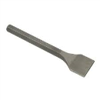
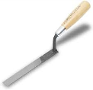
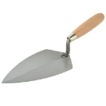
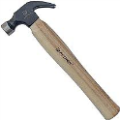

a) b) c) d)

Q8. Which of the following tools is typically used for splitting bricks or stones into smaller pieces during masonry work? (5 Marks)
- Screeds
- Trowel
- Wedges
- Spade
Q9. Which power tool is best suited for cutting tiles for a home improvement project? (5 Marks)
- Power wet saw
- Tile cutter
- Vibrator
- Grinder

Practical Question
Assistant Mason (CON/Q0102), Level-3
CON/N0101: Erect and dismantle temporary scaffold of 3.6meter height.
Infrastructure & Tools :

Infra - Store room, Class room for 30 candidates, Practical yard (30 meter x 30 meter),

Tools & materials - Measuring tape, hammer,, hand drill, water/spirit level, marking chalk/pencil, nails, line Dori, plumb bob, bamboos & ballis, acrow span, H-beam, foot plates, U heads, base plate, couplers, joint pin, Ledger beam, Vertical scaffold member, guard rails. toe board, ring spanner, open ended spanner, plumb bob.
Sr  No. | Practical skill assessment question | Marks | Duration (Min)
Q1 | Practical scenario: Demonstrate the process of erection and dismantle of scaffolding in a group of four members as per the figure given below?
a) | Identify tools & tackles as per the used for dismantling the scaffolding | 4 | 30 Min
b) | Check for all required scaffolding material and hand tools for dismantle | 4 | 30 Min
c) | Wear all required safety gadgets | 4 | 30 Min
d) | Place and position the dismantle equipments form the scaffolding. | 4 | 30 Min
e) | Provide base support and anchoring as per scaffolding such as pipe/system and check the rigidity of support | 10 | 30 Min
f) | Secure joints in Scaffolding (Types such as Coupler / Knots / Pins) | 15 | 30 Min
g) | Follow proper sequence of the erection and dismantling as per the type of scaffolding | 21 | 30 Min
h) | Check for the verticality and rigidity of structure | 8 | 30 Min
 | 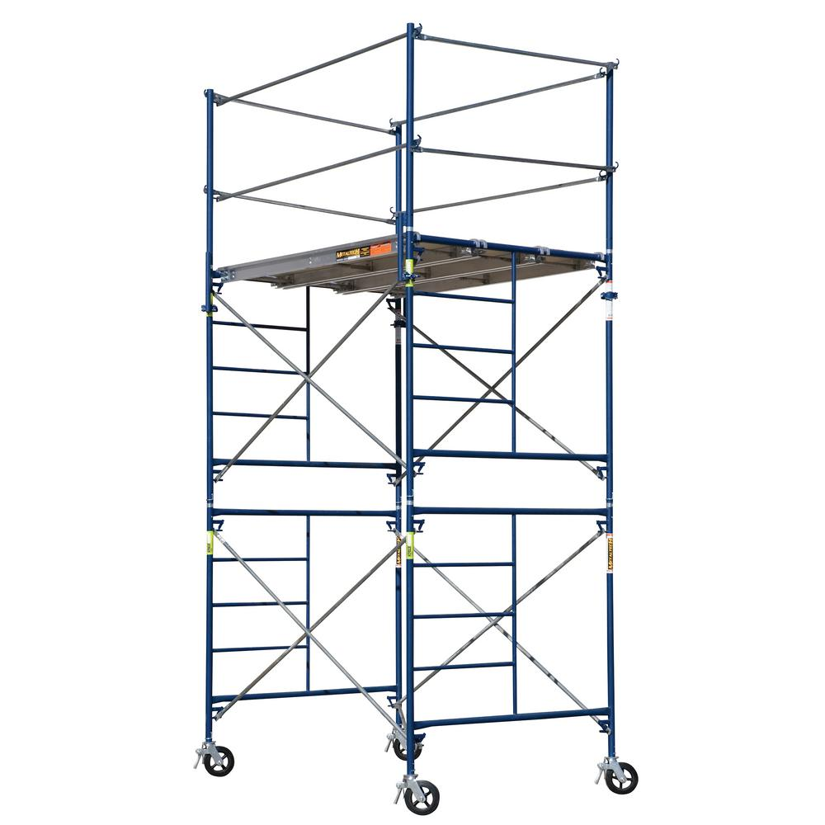 |  | 30 Min
 | Total Marks | 70

